Advocating for Universal Health Coverage: A Workshop | Breakout Room

Introduction

Part 3 of the Toolkit presents step-by-step guidance and templates to advocate for UHC. In this session, we will explore one of the seven steps presented in Part 3.

Step 1: Where is Your Country on the Road to UHC?
Step 2: Who Can Steer Things in a Better Direction?
Step 3: Who Can Join You on the Road to UHC?
Step 4: What Are Your Advocacy Asks?
Step 5: What Are You Going to Do?
Step 6: What Resources Do You Need?
Step 7: How Will You Know You Have Been Successful?

Step 2 is about power mapping — identifying the relevant decision-makers and planning how to influence them.
Learning Objectives
At the end of the session the participants will be able to:
- Identify UHC stakeholders in your country
- Analyse your country’s UHC stakeholders’ influence and power relations

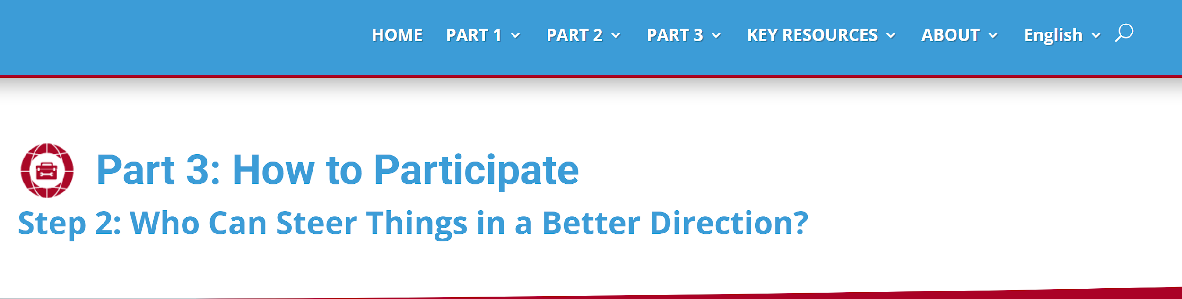
Map Targets

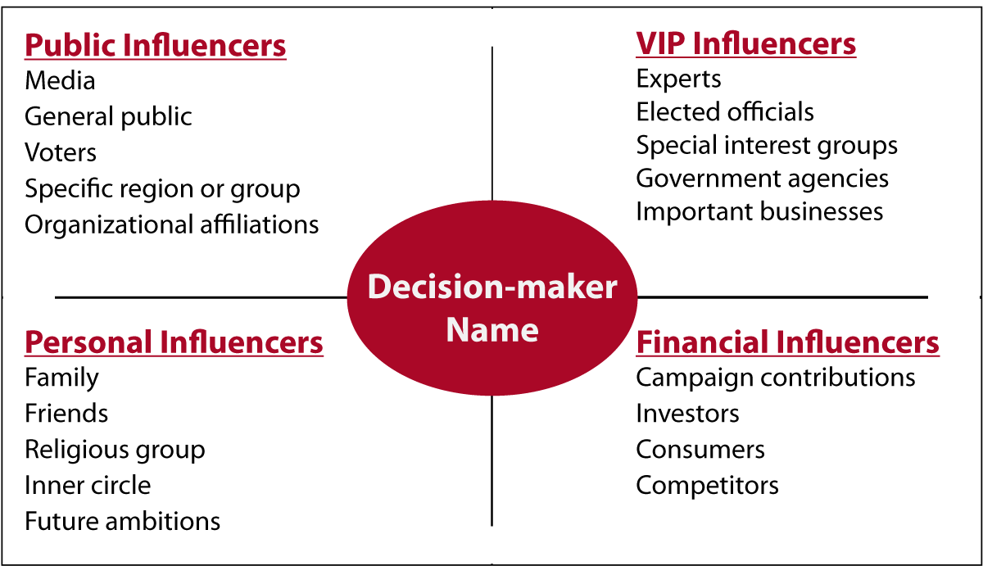

To see it online: https://csemonline.net/lessons/step-2-who-can-steer-things-in-a-better-direction/

Advocating for Universal Health Coverage: A Workshop | Breakout Room
Power Mapping Template

Public Influencers

VIP Influencers

Personal Influencers

Financial Influencers

Decision-Maker

Advocating for Universal Health Coverage: A Workshop | Breakout Room
Direct Contacts

